Rich Thompson’s Trio “Generations 6.0”
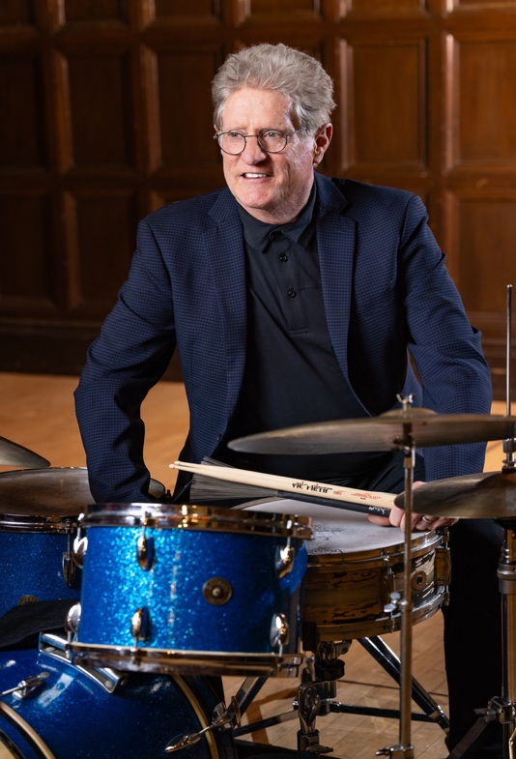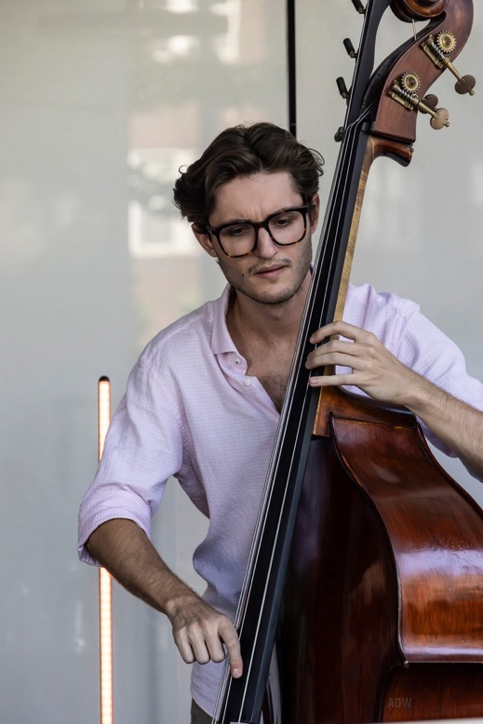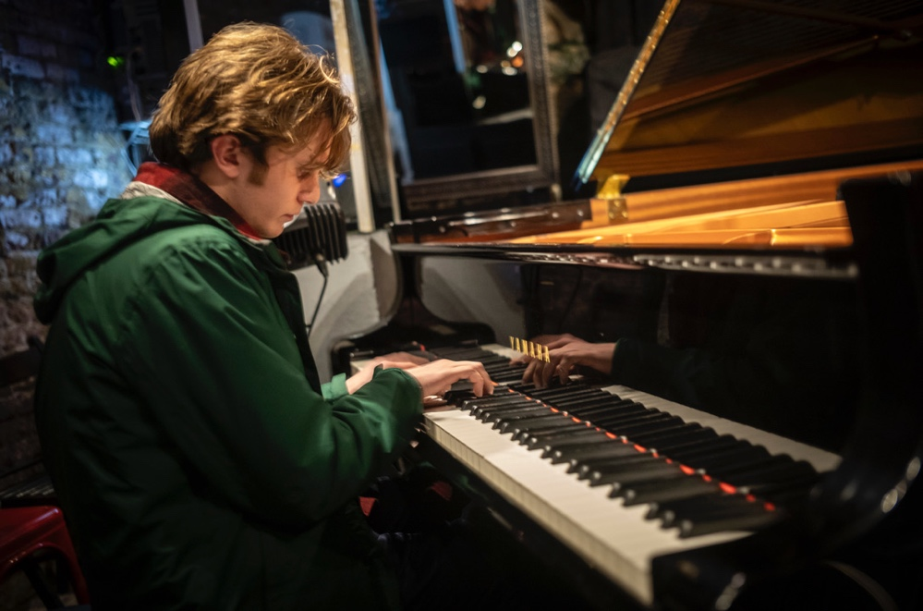

Contact
For more information about the trio, past performances, and future bookings, contact:
Rich Thompson - rdtrhythm@gmail.com 585-233-6900
For an EPK of this trio, visit www.richthompson.net and click on the EPK tab at the top. A new CD of the Trio will be available at the venue! Check out the link below for a listen to “Generations” Trio
https://originarts.com/recordings/recording.php?TitleID=82616

Bios
Rich Thompson

Drummer Rich Thompson has been in demand as a top call drummer in Rochester for the past 30 years. Besides serving as the drum set instructor at the Eastman School of Music since the fall of 1996, Rich has toured, performed, and recorded with the “who’s who” of jazz greats including pianist James Williams (Art Blakey and the Jazz Messengers), The Count Basie Orchestra, Tito Puente, Frank Foster, The Byron Stripling quartet, saxophonist Rich Perry, the Bill Dobbins Trio, Harold Danko, Marion McPartland, Trio East (which includes Clay Jenkins and Jeff Campbell), trumpeter Snooky Young, guitarist Gene Bertoncini, Carl Fontana, Phil Woods, Joe Pass, and a host of others too numerous to mention. The Boston Globe cited Rich as “the drummer who drove the Basie sound,” when he appeared with them at the Boston Jazz and Blues Festival.
Rich has been touring this country and abroad with the Byron Stripling Quartet for the past fourteen years. His CD “Generations” was released in May of 2012 on Originarts.com. It was included on the long list for two Grammys. His CD entitled “Less is More” was recorded with trumpet sensation Terell Stafford, pianist Gary Versace, and bassist Jeff Campbell and was released March 2013 on Origin Records also. In 2016 Rich recorded “Have Trumpet Will Swing” w/the Bryon Stripling Quartet and in 2017 “I Believe in You” with the group Triocity was released. Triocity features multi saxophonist/reedman Charles Pillow and bassist Jeff Campbell. His new Rich Thompson Quartet CD entitled “Who Do You Have to Know,” on Origin Records, was just released this March 17th, 2023.
Rich performs regularly with numerous symphonies in the U.S. and Canada, on the world renowned “Jazz Cruise” and in jazz clubs throughout the U.S. and Europe with the Byron Stripling quartet. His clinics and performances have taken him as far as France, Thailand, Japan, Switzerland, and Newfoundland. Rich has written four drum set books published by Kendor Music USA and Advance/Schott Music-Germany. Rich’s trio “Generations” performed 2 sets at the 2023 and 2025 Rochester International Jazz Festival! Earlier this year, Rich was the director/guest performer with the 2026 Louisiana All State Jazz Ensemble and a guest performer w/the LSU Jazz Ensemble, both at the LMEA convention in New Orleans. Visit Rich on his website to listen to clips or watch a video of his trio at the Rochester International Jazz Festival. www.richthompson.net Visit his “YouTube” channel for additional videos!
Daniel Zawel is a jazz pianist from Ithaca NY. He completed his JCM degree in jazz piano at the Eastman School of Music in 2026 and is currently pursuing his MM degree at the prestigious Manhattan School of Music in New York City. While in Rochester, Daniel became a top call pianist/organist in many of the jazz venues in and around western New York. He performed w/the Labarbara brothers on the Rochester Music Hall of Fame Awards show last May. He performed in the Rich Thompson “Trio Generations” group for the last year he was at Eastman, as well as performing w/Christine Jensen’s Eastman Jazz Ensemble alongside many grad students in recitals and various recordings on and off campus. Daniel is a force to be reckoned with; someone you will be hearing a lot about in the very near future.

Lee Wolf is a bassist, composer, and educator, recently relocated to Pullman, Washington from Rochester, New York. After completing degrees in Jazz Studies and String Bass Performance at the University of North Florida, he moved to Rochester to study Jazz Writing at the Eastman School of Music with Bill Dobbins. His compositions and arrangements have been performed by the Eastman Jazz Ensemble and Studio Orchestra, UNF Jazz Ensembles 1 and 2, and his own Lee Wolf Big Band and East Winds chamber ensemble. Having completed his Doctor of Musical Arts degree and Certificate of Advanced Achievement in Music Theory Pedagogy at Eastman, Lee is now a Lecturer at Washington State University, where he teaches jazz bass, jazz combos, jazz history, and music theory. Lee continues to maintain an active career as a performer with nationally and internationally acclaimed artists and bands including Jazz Northwest, Greg Yasinitsky's YAZZ Band, Sidestep, the Hasselback family, Rich Thompson's Trio Generations, the Laura Dubin Trio, and more.

